- Navigate to the wave on a string simulator.

http://phet.colorado.edu/sims/html/wave-on-a-string/latest/wave-on-a-string_en.html

Once there, select the “No end” option and the “Oscillate” option
INCLUDEPICTURE "C:\\..\\..\\Temp\\SNAGHTML5f73a17.PNG" \* MERGEFORMATINET INCLUDEPICTURE "C:\\..\\..\\Temp\\SNAGHTML5f73a17.PNG" \* MERGEFORMATINET 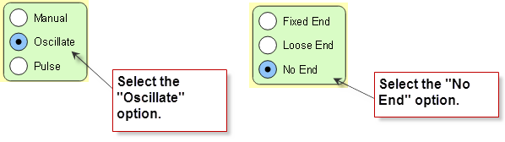

Locate the frequency slider. Move it back and forth and observe how the wavelength changes.

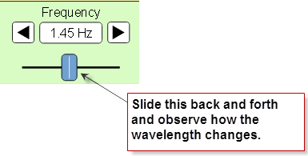
- When you increase the frequency, what happens to the wavelength? Does it increase or decrease?

- When you decrease the frequency, what happens to the wavelength? Does it increase or decrease?

- What is the relationship between frequency and wavelength? Is it inverse or direct?

- Refer to the colors below. Sort the colors from low to high with respect to frequency.

Color Range | Order of frequency (1 = lowest)
Reds

Oranges

Yellows

Greens

Blues

Violets

- Answer the following
- Are the wavelengths of ultra-violet light longer or shorter than that of visible light?

- Are the frequencies of ultra-violet light longer or shorter than that of visible light?

- Are the wavelengths of infra-red light longer or shorter than that of visible light?

- Are the frequencies of infra-red light longer or shorter than that of visible light?

- Now return to the simulator (http://phet.colorado.edu/sims/html/wave-on-a-string/latest/wave-on-a-string_en.html) Select the “Manual” option.

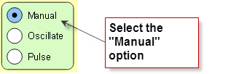
Move the wrench up and down as fast as you can and observe the wavelength. Now move the wrench up and down slowly and observe the wavelength.

- When you moved the wrench up and down quickly (high energy), what happened to the wavelength? Did it increase or decrease? What happened to the frequency? Did it increase or decrease?

- When you moved the wrench up and down slowly (low energy), what happened to the wavelength? Did it increase or decrease? What happened to the frequency? Did it increase or decrease?

- What is the relationship between energy and wavelength? Is it inverse or direct?

- What is the relationship between energy and frequency? Is it inverse or direct?

- Refer to the colors below. Sort the colors from low to high with respect to energy, frequency, and wavelength.

Color Range | Order of energy  (1 = lowest) | Order of wavelength  (1 = smallest) | Order of frequency  (1 = smallest)
Reds

Oranges

Yellows

Greens

Blues

Violets

- Navigate to the following simulation (be patient, it takes some time to load)

https://phet.colorado.edu/sims/cheerpj/photoelectric/latest/photoelectric.html?simulation=photoelectric

Move the wavelength slider to the red light,

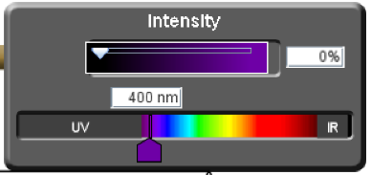

Move the Intensity slider to 100%.

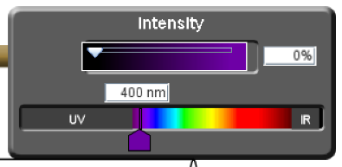
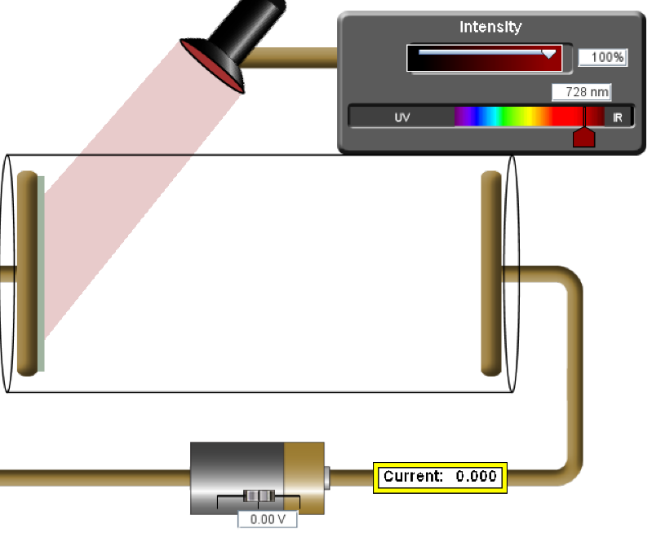
Observe the metal plate that the light is shining on. If electrons are ejected, the current field will be greater than zero.

- Are electrons being emitted when red light shines on the metal? Why not?

- Gradually move the wavelenght slider to the left, until you see electrons begin to fly off the left plate. At what wavelength does this occur?

- Observe the speed of the electrons given off. Now, decrease the Intensity of the light by sliding the Intensity slider to the left, but not all the way to zero. Does the speed of the electrons change? Why or why not?

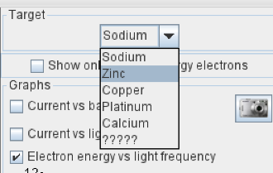
- Use the drop down to change the metal from sodium to zinc. Move the wavelength slider to the left until you see electrons begin to fly off the metal. At what wavelength does this occur?

- Observe the speed of the electrons flying off the metal. Now move the slider all the way to the left. How does this change the speed of the electrons? Why?

- Was the energy required to eject electrons from zinc higher or lower than that of sodium? Propose a theory why?

- Refer to the diagram below to complete the following
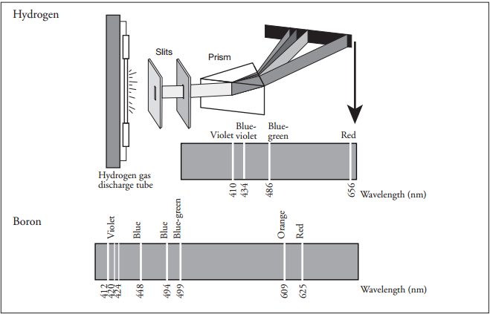
(a) Use colored pencils to color the hydrogen and boron spectral lines within their respective spectra.

(b) List the spectral lines for hydrogen gas by color and corresponding wavelength. Sort the colors from low to high with respect to energy.

Color | Wavelength | Order of energy (1 = lowest)

- Navigate to the following link,

https://sites.google.com/a/boiseschools.org/bohratom/

Navigate through the tutorial then complete the following questions.
- Is energy absorbed or released for the electron transition shown in the diagram to the right? How do you know? | 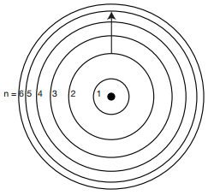
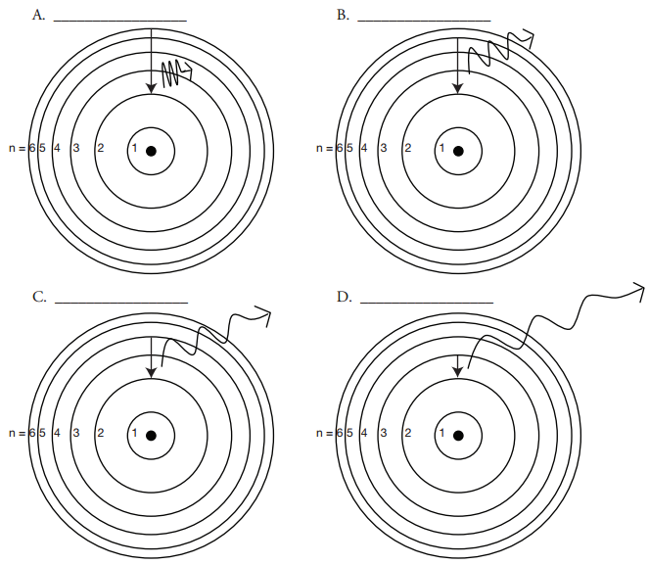

- The diagram above shows the allowed transitions in the hydrogen atom.

- For the transitions shown, is light being absorbed or emitted? How do you know?

- Complete the following table. Refer to the spectrum you colored in “Skill 8.02 Problem 1” to identify the color of emitted for each transition.
Picture | Transition | Color of light | Order of energy (1 = lowest)
A | n= to n=
B | n= ___ to n= ____
C | n= ___ to n= ____
D | n= ___ to n= ____

- What is the relationship between the transition and energy of light emitted? In other words, as the length of the transition increases, does the energy that is emitted increase or decrease?

- Refer to the diagram above then rank the following from low to high with respect to energy.
Energy | Order of energy (1 = lowest)
Gamma rays
X-rays
Radio waves
Visible light
Ultra-violet
Infrared

- Refer to the diagram to complete the following
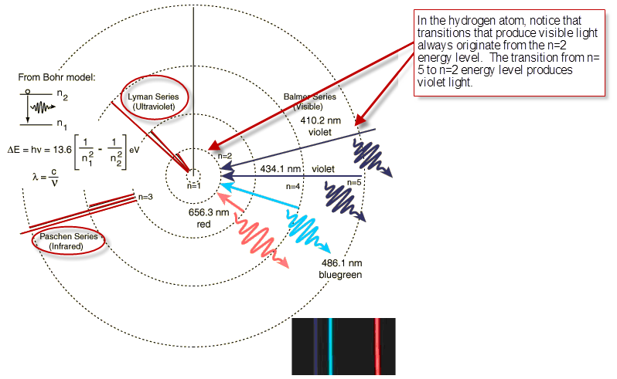
- The diagram above shows transitions that result in Infrared energy, Ultra Violet energy, and Visible energy. Notice that visible always originates from the n=2 energy level. From which energy level does.

- Infrared energy originate?

- Ultraviolet energy originate?

- Complete the follow table. Rank each energy according to the energy level from which the electron originated. Rank each from high to low with respect to energy.

Energy | Distance from the nucleus (1 = closest) | Order of energy (1 = lowest)
Ultra violet
Infrared
Visible

- What is the relationship between the distance from which an electron originates and its energy. In other words, do electrons that originate closer to nucleus have higher or lower energy than electrons that originate farther from the nucleus? Write a sentence that describes this relationship.

- The graph below shows the relationship between the mass number of an atom and the binding energy.
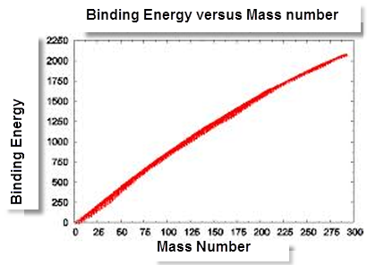
  - According to the graph, is the relationship between binding energy inverse or direct? In other words as the mass number increases does the binding energy increase or decrease?

  - Is the relationship between the number of protons in an atom and the binding energy inverse or direct?

  - Consider the following atoms, rank the atoms from low to high with respect to binding energy: H, He⁺, Ne²⁺

  - Now consider the following transition.

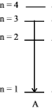
Complete the table to show how the energy released compares between different atoms.
Atom | Order of energy (1 = lowest)
He⁺
Li²⁺
H
Be³⁺

